Department:

Higher Education and Training

# REPUBLIC OF SOUTH AFRICA

AUGUST EXAMINATION

NATIONAL CERTIFICATE

# FITTING AND MACHINING THEORY N2

## (1 1022032)

22 July 2014 (Y-Paper)

Calculators may be used,

This question paper consists of 9 pages and 1 formula sheet.

('i

DEPARTMENT OF HIGHER EDUCATION AND TRAINING

## REPUBLIC OF SOUTH AFRICA

NATIONAL CERTIFICATE

### FITTING AND MACHINING THEORY N2

TIME: 3 HOURS

MARKS: 100

NOTE: If you answer more than the required number of questions, only the required number of questions will be marked. All work you do not want to be marked must be clearly crossed out.

INSTRUCTIONS AND INFORMATION

Answer ALL the questions in SECTION A

Answer ONLY TWO questions in SECTION B

#### Answer either QUESTION 1 .1 OR of QUESTION 1

Read ALL the questions carefully.

Number the answers according to the numbering system used in this question paper.

Write neatly and legiblyiJi

(i -3-

ALL THE QUESTIONS IN SECTION A.

QUESTION 1: OCCUPATIONAL SAFETY

#### Answer QUESTION 1 .1 or QUESTION 1.2

1 . 1 Indicate whether the following statements are TRUE or FALSE with regard to safety in the workplace. Choose the answer and write only 'true l or 'false l next to the question number (1 .1 .1—1 .1 .5) in the ANSWER BOOK.

1 .1 .1 Overhead transmission belts must be provided with guards

1 . 1 .2 When using a ladder, never secure the top part by means of a rope.

. 1 .3 Fixed guards only move with each operation of the machine.

1 . 1 .4 The manufacturerl s information on a pressure vessel includes the date of export.

1 .1 5 A machine must be stopped immediately, if it becomes a danger to those working in the area.

(5)

#### OR

12 Indicate whether thefollowing statements are TRUE or FALSE with regard to safety in the workplace. Choose the answer and write only 'true' or Ifalse l next to the question number (1 .2.1—1 .2.5) in the ANSWER BOOK.

1 2.1 After a heatihg task is performed in a mine, a competent person must inspect the area to ensure there is no possibility of a fire breakingout.

•1-2.2 Pdaked lights are allowed BUT may not be left close to flammable material that may cause a fire or an explosion.

•1 2.3 Smoking is ONLY allowed in the lifting cage.

192.4 No welding, flame-cutting or flame heating is to take place in a mine, unless fire extinguishers have been provided.

1 2.5 Calcium carbide is not to be taken underground unless it is in a water tight container approved by the manager.

(5)

[5]

##### 2: COUPLINGS

2.1 Name FIVE different types of RIGID couplings.

2.2 Give TWO reasons why it is necessary to ensure the correct alignment of a fixed coupling.

3: LIMITS AND FITS

A shaft is to be fitted into a bush. The sizes given for the bush and shaft are:

##### BUSH SHAFT

mm -0,00, mm

3.1 Determine the following:

3.1 .1 The minimum allowance of the fitted parts

3.1 .2 The maximum allowance of the fitted parts

3.1 .3 The tolerance on the shaft

3.1 The tolerance of the hole (4)

3.2 What is the classification of this type of fit? (1)

[5]

##### QUESTION 43 BEARINGS

4.1 State one property of each of the following bearing materials:

White metal

|  |  |
| --- | --- |
| 4.1 2 | Cast iron |
| 4.1 .3 | Bronze |
| 4.1 .4 | Nylon |
| 4.1 .5 | Teflon |

(5)

4.2 Name the THREE types of rolling elements used in the manufacture of antifriction design. (3)

(i

filON 5: LUBRICATION AND VALVES F!GWRF 1 represents a method of lubrication.

##### FIGURE 1

Name this type of lubrication.

|  |  |
| --- | --- |
| Briefly describe this lubrication method.  5.3 State TWO functions of valves in fluid power systems.  5.4 Differentiate between a normally open and a normally closed valve. | (4)  (2)  (2) |

[9]

### QUESTION 6: PACKING, STUFFING BOXES, JOINTS AND WATER PIPE SYSTEMS

6.1 FIGURE 2 9howst3€ FOUR types of joints that allow for expansion and contraction in pipelines. Name these FOUR types of joints. Write only the answer next to the question number (6.1.1 — 6.1.4) in the ANSWER BOOK.

|  |
| --- |
| 6.11  6.1.3  6.1.4 |

(4)

#### FIGURE 2

6.2 List FOUR important guidelines to ensure the proper fitting of 0-rings and seals in hydraulic systems. (4) [8]

#### (i

##### 7: PUMPS

|  |  |  |
| --- | --- | --- |
| 7.1 | State TWO methods of neutralising water hammer in plunger pumps. | (2) |
| 7.2 | Refer to FIGURE 3 and describe the operation of a double-acting plunger pump by inserting the correct letters for the various valves. Write only the answer next to the question number (7.2.1 — 7.2.4) in the ANSWER BOOK.  Stroke 1:  As the plunger moves upwards, water enters the chamber through the inlet |  |

valve (7.2.1 ), and delivers water past the outlet valve (7.22),

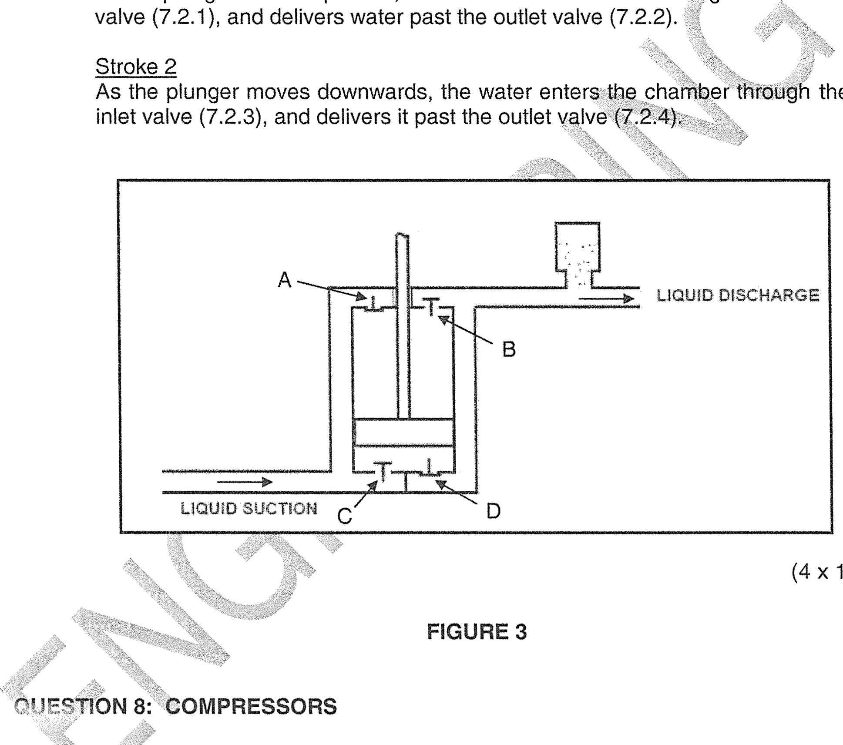

the

Stroke 2 inlet valve (7.23), and delivers it past the outlet valve

(4) [6]

##### FIGURE 3

Explainth@function of each of the following compressor components:

8.1 Filter

8.2 Drain Valve

8.3 Intercooler

8.4 After cooler

8.5 Pressure regulator switch

###### O'JFST!ON 9: V-BELT, CHAIN, GEAR DRIVES AND REDUCTION GEARBOXES

|  |  |  |  |  |  |  |  |  |
| --- | --- | --- | --- | --- | --- | --- | --- | --- |
| 9.1 State TWO advantages of chain drives when compared to gear drives.  9.2 State TWO reasons for the need to eliminate excessive sag on chain drives.  9.3 Name THREE different types of sprockets associated with chain drives.  TOTAL SECTION A:  SECTION B  ANSWER ONLY TWO OF THE QUESTIONS IN SECTION B  QUESTION 10: PNEUMATICS AND HYDRAULICS  10.1 Explain the function of a pressure relief valve in a ydrauli&system.  10.2 State FIVE factors which influencethe choice of pneumatics over hydraulics for transmitting power to machines.  10.3 Identify the FIVE hydraulic components shown in FIGURE 4. Write only the answer next to the question number (10.3.1!8 — 10.3.5) in the ANSWER BOOK. | | | | | | | | (2)  (2)  (3)  [71  60  (1)  (5)  (5) |
| 10.3.1 | 10*3.2 | 103.3 | 1043.4 | 10.36 |
| FIGURE 4  10.4 State FIVE basic aspects of inspection in the routine maintenance of a hydraulic circuit  10,5 Name the FOUR components which make up a pneumatic service unit.  QUESTION 11: CENTRE LATHE  1 1 .1 State FOUR advantages of the use of mandrels for the machinist.  1 1 .2 Name the TWO methods for setting over the tailstock in preparation for taperturning on the centre lathe.  1 1 .3 A taper of included angle 60 (SIX DEGREES) has to be turned on a workpiece 280 mm long. Calculate the amount of tailstock set-over required. | | | | | | | (5)  (4)  [201  (4)  (2)  (3) | |

11 4 A round shaft with a pitch diameter of 100mm must be provided with a twostart square thread with a 5 mm pitch. The clearance angle is 30 .

(1

Calculate:

|  |  |  |
| --- | --- | --- |
|  | the helix angle of the thread | (3) |
|  | the leading angle of the cutting tool the following angle of the cutting tool | (1 ) |
| 1 1 .5 | Explain the following terms applicable to CNC machining incremental programming |  |
|  | 1 1.5.2 Absolute programming | (1 ) |

1 1 .6 List FOUR items of information required by the parts programmer when writing a CNC machining programme. (4)

[20]

###### QUESTION 12: MILLING MACHINES AND SURFACE GRINDERS

12.1 Name the FOUR types of milling cutters shown in FIGURE 5. Write only the answer next to the question number (121.1 — 12.1 A) in the ANSWER BOOK.

|  |  |  |
| --- | --- | --- |
| 12.1.1 | 121.2 | 121.3 |

(4)

##### FIGURE 5

1 2.2 RWork-piece must have 13 gear-teeth machined on its circumference.

12.21 What type of indexing would you perform on this gear blank?

12.2.2 Calculate the required indexing, using a Cincinnati dividing head as shown below

(i -9_

|  |  |  |  |  |  |  |  |  |  |  |  |  |
| --- | --- | --- | --- | --- | --- | --- | --- | --- | --- | --- | --- | --- |
|  |  |  | The Cincinnati Dividin | | | | | Head | |  |  |  |
| Side  1 | 24 | 25 | 28 | 30 | 34 | 37 | 38 |  | 39 | 41 | 42 | 43 |
| Side 2 | 46 | 47 | 49 | 51 | 53 | 54 | 57 |  | 58 | 59 | 62 | 66 |

12.3 State TWO advantages of the down cut milling process

State TWO disadvantages of the down cut milling process

12.5 State FOUR factors related to the workpiece, which will help you to select the correct grinding wheel.

12.6 Name THREE types of bonding materials which holds the abrasive particles in grinding wheels together.

[20]

|  |  |
| --- | --- |
| TOTAL SECTION B: | 40 |
| GRAND TOTAL: | 100 |

###### FITTING AND MACHINING THEORY N2

FORMULA SHEET

#### f=ftx TxN

TDN 60

##### S = ZDN

40

D de length of workpiece

Set- over =

lepyth Of taper

Leading angle = 90 0 - (Helix angle + clearance angle)

Following angle =90 0 + (Helix angle - clearance angle)

Lead = No of starts x pitch

higher education & training

Department:

Higher Education and Training

REPUBLIC OF SOUTH AFRICA

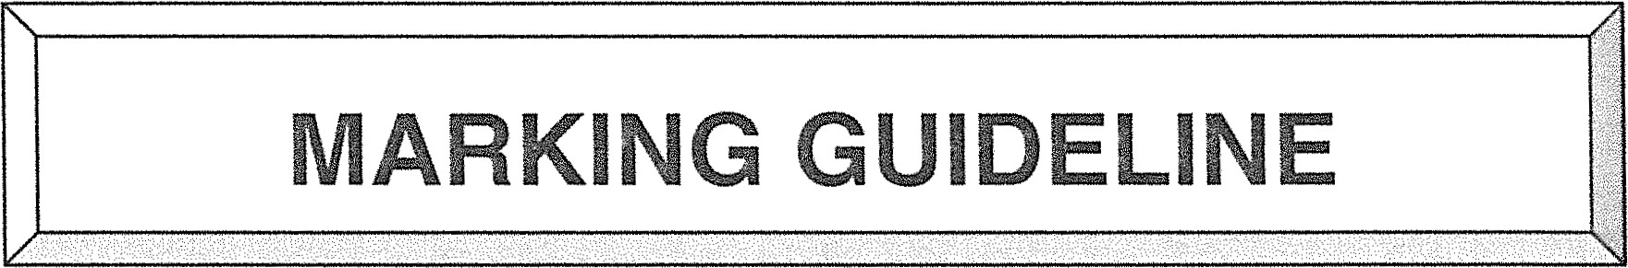

# NATIONAL CERTIFICATE

AUGUST EXAMINATION

FITTING AND MACHINING THEORY N2

# JULY 2014

This marking guideline consists of 8 pages.

Al = 1/2 mark

 = 1 mark

MARKING 

FITTING

## QUESTåON 1: OCCUPATIONAL SAFETY

1 .1True

### 1 .2 False

1 .3 False

1 .4 False

1 .5 True

 (5)

### OR

1 .2 1 .2.1 True

1 .2.2 False

1 .2.3 False

I .2.4 True

1 .2 5 True

 (5)

[5]

## QUESTION 2: COUPLINGS

2.1 Flange

 Gear

0 Marine

### Chain

 Fluid (5)

2.2 Efficient operation of machinery

 Cost savings of the maintenance materials  Lengthens the life-span of components

 Minimize downtime and the need for overtime

(Any 2 x 1) (2)

[7]



## 3: LIMITS AND FITS

3.1 .1 0,01 mm

3.1 .2 0,08 mm

3.1 .3 0,02 mm

|  |  |  |  |  |
| --- | --- | --- | --- | --- |
| 3.1 .4 0,05 mm | | |  | (4) |
| 3.2 Clearance fit | | |  | (1)  [5] |
| QUESTION 4: | | BEARINGS |  |  |
| 4.1 | 4.1 .1  4.1 .2  4.1 .3    4.1 .5 | Embeddability  Compatibility  High load carrying ability  Embedability  Resistance to seizure Corrosion resistant  Low coefficient of friction Heat resistant  No lubrication required  Low coefficient of friction  Self-lubricating  Corrosion resistant  High operating temperatures | (Any 1)  (Any 1)  (Any 1)  (Any 1) | (5) |
| 4.2 | Ball  Roller  Spherical roller  Needle roller | |  |  |
| QUESTION 5: LUBRICATION AND VALVES | | | (Any 3 x 1) | (3) |
| 5.1 Oil ring lubrication or splash feed lubrication | | |  | (1 ) |

5.2 The ring is in rolling contact with the shaft and the lower part is dipped in the oilM As the shaft rotates the oil is brought up by the ring and is distributed along the shaftM Gradually, the oil drips back into the sump due to gravity.vz (4)



FilTlNG

 A valve is used to control the direction of flow.

 A valve is used to control pressure. (2)

5.4 Normally open valves are designed to be opened when in use whereas a normally closed valve is closed during normal use. (2)

## QUESTION 6: PACKING, STUFFING BOXES, JOINTS AND WATER PIPE SYSTEMS

6.1 6.1 .1 Corrugated expansion

6.1 .2 Expansion U-Joint / Expansion bend

6.1 .3 Full Loop

6.1 .4 Horseshoe (4)

6.2 Clean all surfaces thoroughly

 Ensure no-Uamage to the oil ring or the suffaces

 Use the correct seal

 Lubricate the seal before fitting

Protective sheath to be used when fitting a ring seal or O-ring over a sharp ridge or threaded section

0 T-jgb.t-e-n-upJi.gN!y ensuring that the ring seal fits squarely

(Any 4 x 1) (4)

[8]

## QUESTION 7: PUMPS

7.1 open and close valves gradually o use an air chamber in the delivery line (2)

7.2 72.1 c

72.2 

72.3 

72.4  (4)

[6]

### QUESTION 8: COMPRESSORS

8.1 Ensure the intake of clean air, free of dirt and other foreign matter.

8.2 Used for draining water or moisture, which accumulates inside the air receiver.

8.3 Cools air between the low pressure and high pressure stages before entering the high-pressure cylinder.

8.4 Cools air after the high-pressure stage of compression before being stored in the air receiver.

8.5 Allows the compressor to be switched off electrically, after the prescribed pressure has been reached.

 [5]

## QUESTION 9: V-BELT, CHAIN, GEAR DRIVES AND REDUCTION GEARBOXES

9.1 Transmits motion over long-distances

 Transmits motion to more than one drive at a time

 Easier to maintain

 Relative cheap

|  |  |  |  |
| --- | --- | --- | --- |
| (Any 2 x 1)  Destructive to the chain  Detrimental to smooth running C.IQL.e.ffigie.!LCY.)  CausEUbjppjng and vibration (chain-could-cc-mg-Qjfib.Q-s.QLQde-t) | | | (2) |
| Could ruin the sprockets (gauge-unneces-sau--w-e.al)  (Any 2 x 1)  9.3 Solid sprocket  Solid sprocket with spokes | | | (2) |
| Split sprocket with spokes | | | (3)  [7] |
| TOTAL SECTION A:  SECTION B  QUESTION 10: PNEUMATICS AND HYDRAULICS | | | 60 |
| 10.1 | Ensures that the normal working pressure is not exceeded by relieving excess | |
|  | fluid pressure in the tank. |  | (1 ) |
| 10.2 | Noise factor  Cost factor  Power to weight ratio required  Cleanliness factor  Speed factor  Rigidity factor |  |  |
|  |  | (Any 5 x 1) | (5) |
| 10 3 | 10.3.1 — 2/2 Way Directional Control Valve  10.3.2 - 4/3 Way Directional Control Valve  10.3.3 - 5/2 Way Directional Control Valve  10.3.4 - 3/2 Way Directional Control Valve |  |  |
|  | 10.3.5 - 4/2 Way Directional Control Valve |  | (5) |
| 10.4 | Hose fittinqs and pipes are not loose  Hoses and fittings must seat correctly  Oil and air filters are clean    HQS-E-and-p.ipings-ar.e-clean prior to installation  Release-system-p-cessu.ß to tool before disconnecting  ALLgua@s to be fitted  Before start check that persons are clear of danger |  |  |
|  |  | (Any 5 x 1) | (5) |





10 5 Lubricator

 Water trap

 Drain valve

|  |  |  |  |
| --- | --- | --- | --- |
| 0 Pressure regulator | |  | (4) |
| QUESTION 11: CENTRE LATHE | | (Any 4 x l ) | [20] |
| 1 1 .1 | Setting up time is reduced is guaranteed  Ea!gb-ÆQAuc.tiQ-n of large amounts is possible  Mandrels can be modified to suit a large range of work |
|  | Setting up can be delegated to | (Any 4 x 1) | (4) |
| 1 1 .2 | Graduated sleeve method |  |  |
|  | Dial test indicator method |  | (2) |
| 1 1 .3 | x tan — 2  X = Lxtan— 2  = 280xo,0524 v/ |  |  |
|  | = 14,67 mm |  | (3) |
| 1 1 .4 | 1 1 .4.1 Lead = No.Qf starts>< Pitch  =2x5  = 10 mm  Pitch diameter = OD — —x Pitch  2 |  |  |

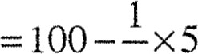

2 = 97, 5 mm

Lead

tan 0 =

Pitch circumference

10



nx97,5

= 0,033

O = tan -1 0.033

1,870

(3)



1 1 .4.2 Leading angle = 900 — (Helix + clearance angle)

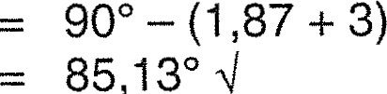 (1)

1 1 .4.3 Following angle = 900 + (helix — clearance angle)

900 + (1 , 870 — 30) 

(1)

88,870

1 1 .5 1 1 .5.1 Incremental — each tool movement refers to the previous/ last tool position (1)

1 1 .5.2 Absolute — each tool movement refers to a fixed point or origin (zero point)

1 1 .6 Material type

 Stock length

 Information from a drawing

 Operating sequence

 Tooling required

 Dwell time

 Coolant application

 Sizes according to dimensioning position

 Cutting speed (4)

(Any 4 x I )

[20]

## QUESTION 12: MILLING MACHINES AND SURFACE GRINDERS

12.1 12.1.1 Square milling

12.1 .2 T-Slot milling

12.1 .3 Ball milling cutter

12.1 .4 End milling cutter (4)

12.2 12.2.1 Simple indexing

40 40 1



N 13 13

12.2.2

= 3 turns and Qf a turn 

13

—x— 13 3 39



3

Required indexing = 3 turns of crank & 3 holes in a 39 hole circle.

(4)

-8- 

FITTING

12.3 Deeper cuts can be made as the force of the cutter is downwards.

|  |  |  |  |  |
| --- | --- | --- | --- | --- |
|  | A finer finish is obtained | |  | (2) |
| 12.4  12.5  12.6 | Vibration in the arbor is unavoidable  A finer feed is to be used  Material with hard scales could cause damage to the cutter teeth | | (Any 2 x 1)  (Any 4 x 1)  (Any 3 x 1) | (2)  (4)  (3)  [20] |
| Amount of material to be ground  Hardness of the material  Wet or dry grinding  Wheel speed  Surface area  V: Vitrified  B: Resinoin or synthetic  R: Rubber bonding  E: Shellac  S: Silicates |  |
|  |  | TOTAL SECTION B: | | 40 |
|  |  | GRAND TOTAL: | | 100 |